Kimberly Orozco
November 9, 2025
Module 10.2 Assignment
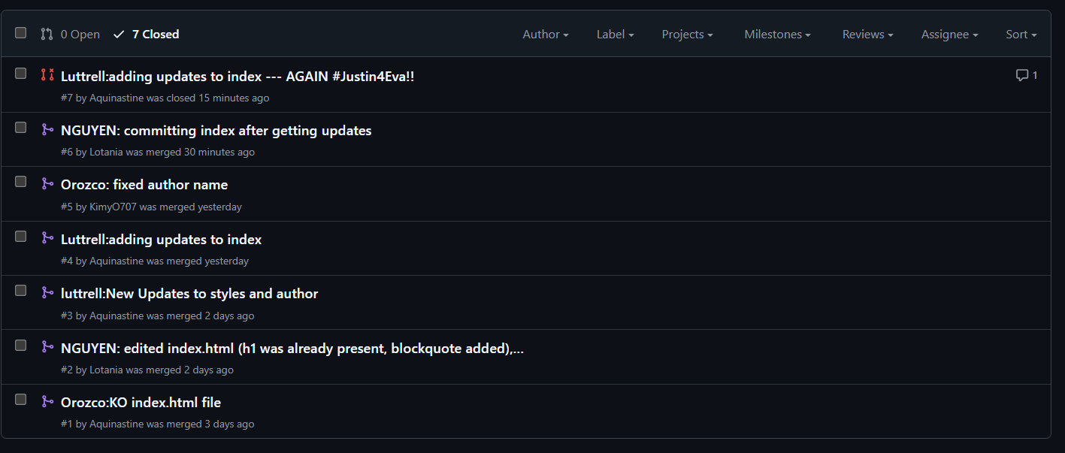
Assignment: Shared Code Repository - Git Exercise

Link to Gitlab: https://github.com/Aquinastine/GitLab
Github username: KimyO707

